Private Public Dialogue
in Mozambique
by
Orlando Conceição

Presented at the Public-Private Dialogue 2010 Workshop
(Vienna, June 1-3 2010)

1- General context

Mozambique is engaged on implementation of a number of business environment reforms in order to become attractive for foreign investments and to empower the local companies and entrepreneurs. In 2008, Mozambique had approved a National Business Environment Reform plan and a matrix of activities that includes 55 reforms in total. The Strategy has a time span of implementation of 5 years (2008-2012). Most of the reforms included in the strategy are based on the private sector matrix and as result of a number of meetings with the private sector.

2- Historic

Public Private Dialogue (PPD) has been acting in Mozambique for more than 10 years. Most of the initiatives are been taken by the private Sector. The private sector is represented by the Confederation of Business Associations (CTA) and the public sector by its representative Ministry of Industry and Commerce (MIC).

There were established a number of platforms and mechanisms for the PPD that include:

- Annual private sector conference with the President (CASP)
- Annual private sector conference in the regions (CASP Regional)
- Consultation meeting with the Prime-Minister (CAC)
- Sectorial Meetings with Ministers and/or National Directorates (Pelouro Meetings)

3- Structure

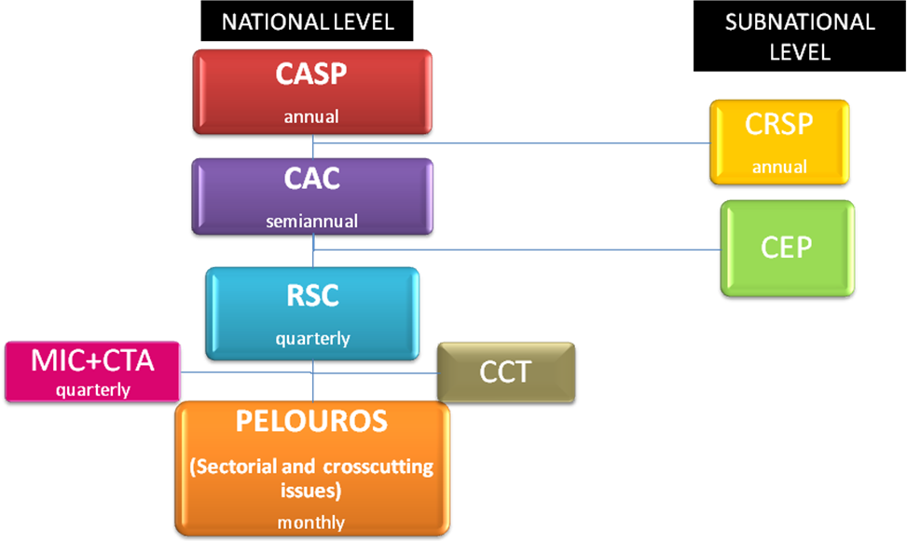

4- Results of the PPD

There a considerable number of success reforms that we can report under this figurine of PPD, although, there still a general perceptions that it could be accomplish more reforms and faster within a different figurine. The recent results we can mention regarding implementation of BER Strategy are the following:

- Elimination of minimum capital to open a company
- Elimination of bank deposit for registry a corporation
- Build a PPP to implement the “Electronic Single Window” project
- Approval of special tax regime for small payers
- Build a PPP to dissemination of information and campaign for tax’s massification
- Reduction of price of electricity for Agriculture sector
- Simplification of procedures for a number of business licenses (Licenciamento Simplificado)

5- Challenges

- Agreements reached in the PPD forums are not cover by a legal demand
- Multi-sectorial issues are more difficult to reach results
- It is difficult to reach integrated actions when interventions of different ministries are required
- There are no formal follow-up mechanisms
- Lack of information from impact of the reforms at subnational level
- Complex and long organizational chart

6- National and Subnational interaction

In order to overcome the challenges, the following organizational chart is currently in discussion.

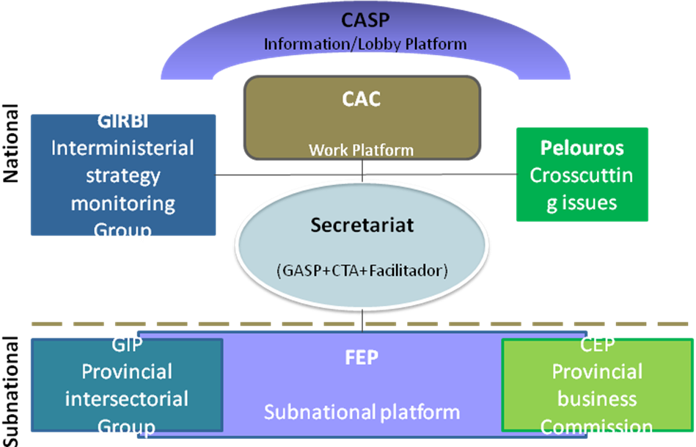

7- Factors of Success

- Updated report on progress of implementation of the strategy (monitoring system)
- Dynamic secretariat
- Communication’s flows functional
- GIRBI meetings structured
- GIRBI meeting agenda very clean and straightforward
- Institutionalization of the figurine to secure the commitment on achievements and agreements resulting from the PPD.
- Sectorial meetings.

Biography of the author

Orlando da Conceição, Executive Director of the Confederation of Mozambican Business Associations (CTA)
Orlando da Conceição holds a Masters in Governance and Public Administration. From 2008 to Date he has been the Executive Director of CTA. He has also acted as researcher for policy reforms to improve the business environment and coordination of the working groups under the Public-Private Dialogue (Consultative Mechanisms). From 2006 to 2008, he was Manager of Membership Development of CTA, providing assistance to companies and business organizations on legal compliance and corporate governance issues and on the establishment of business membership organizations to represent companies on dialogue with Government. From 2003 to 2006, he was Managing Director of Nakosso – Niassa Business Centre, where he implemented a private sector programme sponsored by the Swedish International Development Agency.

